

American International University-Bangladesh (AIUB)  
**Department of Computer Science  
Faculty of Science &Technology (FST)  
Fall 19_20  
CSC 2210 Object Oriented Analysis and Design (OOAD)**

**Section: A  
Group No: 9**

**Smart Home System**

An Object-Oriented Analysis and Design (OOAD) project submitted

By

*Jahidul Hasan (18-38489-2)*

*Bornil Mostafa (17-35574-3)*

*Fatematuj johura (18-37846-2)*

*Zareen Zia (17-35760-3)*

The project will be Evaluated for the following Course Outcomes

|  |  |
| --- | --- |
| **CO3:** Formulate a baseline document to perform feasibility study of a proposed project idea | Total Marks |
|  |
| Project Background Analysis [5Marks] |  |
| Project Content Knowledge [5Marks] |  |
| Project Feasibility Study [5Marks] |  |
|  | |
| **CO4:** Design a Complex engineering problem using UML Tools and explain the system using a project report and presentation | Total Marks |
|  |
| Diagram Standard [5Marks] |  |
| Report Organization [5Marks] |  |
| Presentation Delivery [5Marks] |  |

1. **PROBLEM DOMAIN**
   1. **Project Background Analysis**

Since the dawn of history mankind has been trying to achieve comfort combined with simplicity, as the goal is so bright it still stumbles with lots of obstacles. A home is the place where people usually relax, spend quality time with their families and sometimes even work on their jobs. Building a home went through many phases, at the stone age it was just a cave but now at the 21st century a home might be just a small place or a huge apartment in a skyscraper that would cost millions. The idea of building a smart home is considered a luxury for now but actually in few decades most of the houses will probably be a smart home in a way or another depending on its complexity, efficiency, and cost.

As people lived in their homes a lot of problems popped up which needs to be resolved. Some of the problems that people face in ordinary homes are the waste of energy and other resources, security, and time saving. The smart home solves these problems in a very effective way as for the security smart homes are supplied with surveillance cameras that monitor the whole place form inside and outside. These cameras are connected to the display screens in the house, warning alerts are used and they send out messages to the owner whenever a door or a window is unlocked in an appropriate way or in case the owner is not at the house. Efficiency in the smart house is covered by easy control over all devices available in the home.

* 1. **Project Solution and Feasibility Analysis**

In the world of smart houses different levels and technologies are used, as mentioned before there are different stages of complexity that can be used in designing a smart home, those different levels certainly come with different prices which will change the economical point of view of the customer, as he will decide their choice upon the allowed, needed, and the affordability of their home. As we all know the performance varies with the kind of level and complexity so the very famous and well-known saying is applied “the more you pay, the more you get”. The difference in the price could be due to different reasons, for example the quality of components used which will differ in the lifetime of system and its reliability. The price would also differ due to the different options available in the smart home. The design is chosen to be simple but effective, full of features but not expensive, the reason for this choice is to provide a good smart home with a low price. Although it’s clear that our design if full of components but actually it is not highly priced, the economical view is taken in consideration to help in finding the most flexible and efficient home. A lot of smart homes are more complex than this design but we choose the most important and needed issues to solve. From the view of maintainability, our design is very easy to be maintained, there is no need to bring an expert each time a problem is found, any issue can be fixed in an easy and fast way, in other words people living in this smart home can fix any bug by themselves with no need to professional persons.

1. **UML DIAGRAM**
   1. **Use Case Diagram**

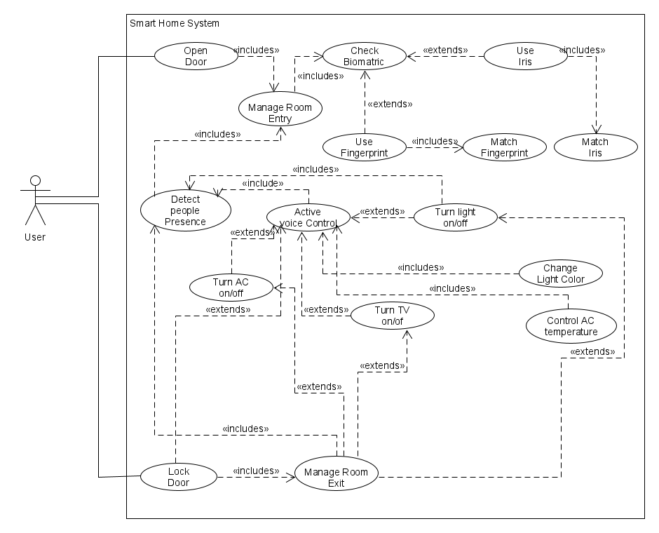

Scenario: In a smart home system user have put his/her fingerprint or Iris to door manager system via biometric scanner in the case of unlock door. After verify the biometrics of user door unlocks and gesture sensor turned on to detect people presence. If there any people enter in the room voice control and lights turned on automatically. User can control turn on/off TV, AC and lights via voice command. And light color and AC temperature can be controlled by voice command. User lock the door via voice command also, but when he is in the room. If there is no people in the room all the devices (lights, TV, AC) will turn off automatically and the door will be locked.

* 1. **Class Diagram**

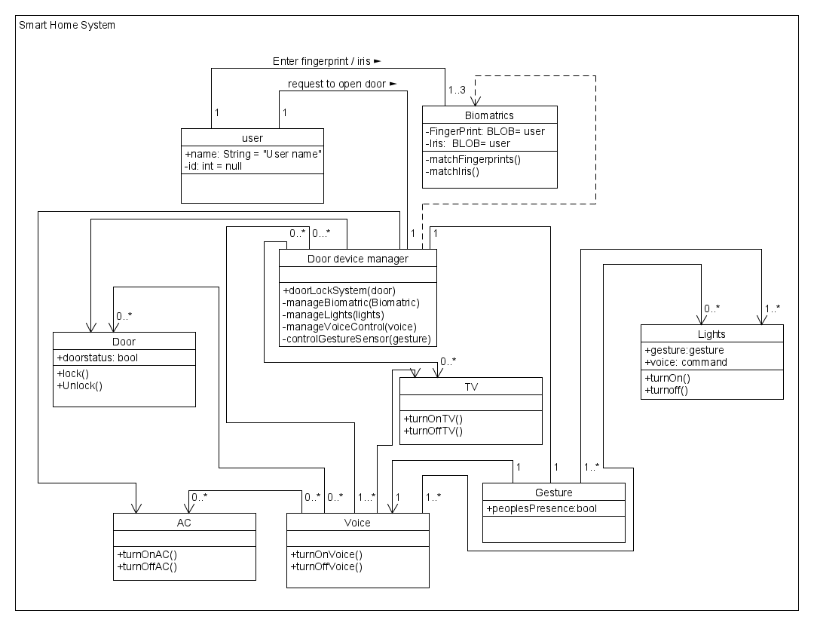

**Scenario:** In a Smart home system, a user can enter his iris or fingerprint to the biometric via the system to open the door. One user can enter biometrics one to three times through door manager device system. The biometric will process by the Door Manager Device. The Door Device manger turns on gesture to indicate whether anyone is present or absent in the room after unlocking the door. There is a Voice control feature in the system. By voice control user can close or open the Door. Also by voice control user can on or off the Lights, TV, and Ac. The door device manager found there is no audience. In the room it will automatically turn off lights, TV, and Ac and locks the door at the last.

* 1. **Activity Diagram**

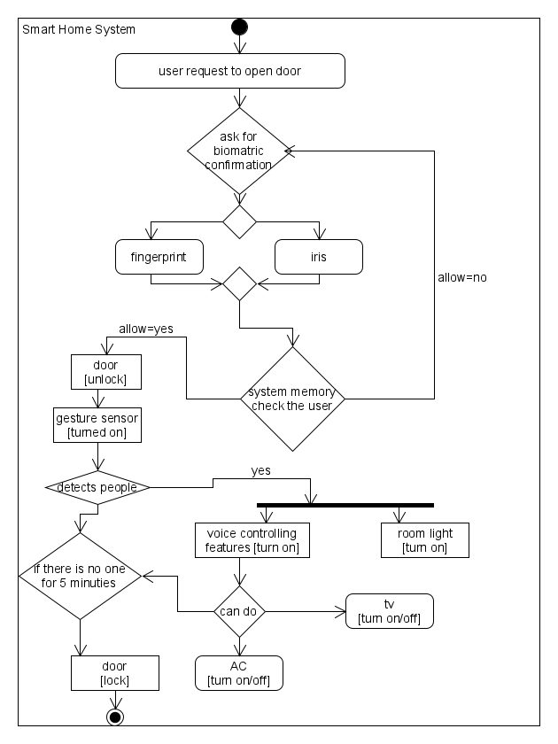

Scenario: A room is locked by smart devices which is being controlled by Door manager device. The Door manager device ask for biometric to user to enter in the room. Door manager device has two option for biometric, Fingerprint and Iris. If the door manager device gets one of them from user taken data will pass to the system memory to check the user is allowed or not. If the biometric does not match system will ask for biometric confirmation again. If the user is allowed the door status will be unlocked and after open the door gesture sensor will turn on. When gesture sensor detects any people presence in the room voice controlling features and room light will turn on at the same time. Peoples will get the features like turn on/off TV/AC via voice command. If gesture sensor cannot detect any people presence in the room for 5 minutes all the devices will turn off automatically and door will be locked. And a user can lock the door via voice command only when he is in the room.

* 1. **Sequence Diagram**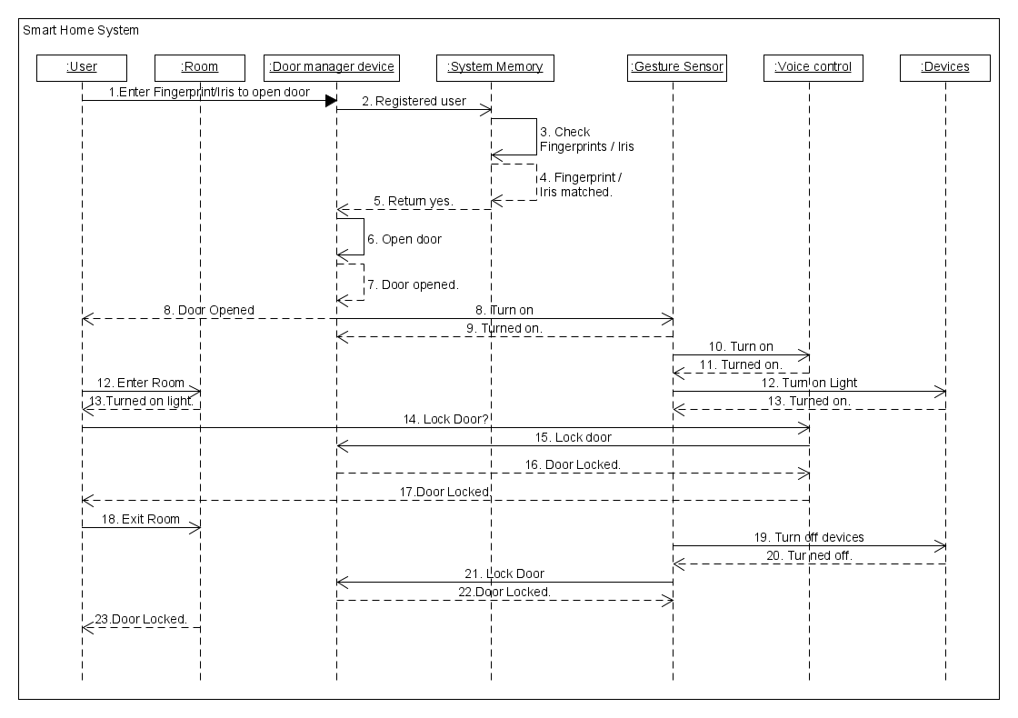

Scenario: To get entry in a smart room user have to put his fingerprint/Iris to Door manager device via biometric scanner. Door manager device send data to the system memory to check the user is registered or not. If the user is registered the door opens and device manager turn on the gesture sensor. If someone enters room when door is unlocked voice control and lights of the room turns on automatically. User can user voice command to lock the door only if he/she is inside the room. If user exits from the room all the devices turn off and door will lock automatically.